INSTRUCTIONS FOR THE PREPARATION OF PAPERS
(EXAMPLE)

Doboku University Regular Member ○Taro Doboku
Doboku University Regular Member Jiro Doboku
Doboku University Student Member Saburo Doboku

1. INTRODUCTION
This document contains detailed guidelines for the preparation of papers to be presented at the International Summer Symposium. You are strongly requested to follow the guidelines. International Summer Symposium will be held as a part of JSCE Annual Conference. Please register and submit your paper in English through the Annual Conference website of JSCE.

2. FORMAT
Papers should be two pages long and must be printed on A4-sized white paper (21.0 cm wide by 29.7 cm long). The left and right margins should be 1.5 cm, the upper and lower margins being 1.8 cm. Use Times New Roman font type. As for the size of the font, it should be 10.5 points or size as close as possible. Your paper should also be single-spaced.

3. PAPER SUBMISSION
Submit full papers in PDF format via the website. → http://committees.jsce.or.jp/zenkoku/
Only online submissions will be accepted. The PDF file size should not exceed 5MB and should not be password protected.

4. ORGANIZATION OF THE PAPER
4.1 Title
Leave one blank lines then type the title of your paper. The title should be in capital letters using 12-point bold typeface. Please center the title. Leave one blank line below the title.

4.2 Authors’ names, affiliations and types of JSCE membership
Type the authors’ affiliations, types of JSCE membership and names using 10.5-point plain typeface. Put “○” before the name of presenter. Each author’s name should appear in the order of the first name, middle name, and last name. The list of authors should be right justify. Leave one blank line under the authors’ names. Below the authors’ information the text of the paper follows and should be 10.5-point size throughout.

5. HEADING
The heading should be left justify and typed in capital letters with bold typeface. The heading must have one blank above and below it. There is no indentation for the paragraph following headings and sub-headings.
The subsequent paragraph must be indented five spaces. Do not leave extra spaces between paragraphs.

5.1 Sub-Heading
Sub-headings should be in upper and lower case with bold typeface. Sub-headings must be flush against the left side of the text. There must be one blank line above sub-headings. Do not leave an extra space below sub-headings. Please use the above-mentioned rules for indentation.

6. EQUATIONS
Equations must be written with the same word processor used for the text, without hand written symbols in order to aid legibility. Equations must be centered and numbered sequentially with their numbers in parenthesis and justified to the right. Please refer to the following equation:
(1)
The equation should be cited in the text as Eq. (1), Eq. (2), etc.

7. FIGURES, TABLES and PHOTOS
Figures and tables should be numbered, for example, Fig. 1, Table 1 or Photo 1. Place table titles above tables and figure titles below figures. Allow one blank line between the titles for tables and figures. Allow one blank line between tables or figures and the adjacent text. The titles for tables and figures should be centered. Figures and tables should be placed close to where they are cited.

Keywords: Instructions, Style, PDF file, Online submission, JSCE Annual Conference
Contact address: Yotsuya 1-chome, Shinjuku-ku, Tokyo, 160-0004, Japan, Tel: +81-3-3355-3442
8. CONCLUSIONS
Write a CONCLUSIONS section at the end of the paper, followed by REFERENCES. References should be listed at the end of the paper in alphabetical order with the first author’s last name and separated by one blank line between each other. Make sure all references are complete, including last names and initials of all authors, year of publication, title of paper or book, name of periodicals, volume number, issue number, publisher (in case of books), city and country of publication, and page number.
References should be cited in the text by indicating the last name of the first author and the year of publication, for instance, Kawashima et al. (1998). If there is more than one paper to be cited as mentioned, place letters a,b,… after the year to distinguish the references, for instance, Kawashima et al. (1998a).

REFERENCES
Kawashima, K., MacRae, G. A., Hoshikuma, J., and Nagaya, K.: Residual Displacement Response Spectrum, Journal of Structural Engineering, ASCE, 124-5, 1998, pp. 523-530.
Kawashima, K. and Penzion, J.: Correlative Investigations on Theoretical and Experimental Dynamic Behavior of a Model Bridge Structure, Report No. EERC 76-26, Earthquake Engineering Research Center, University of California at Berkeley, Berkeley, CA, USA, 1976.
Goldsmith, W.: Impact, Edward Arnold, London, UK, 1960, pp. 1-25.

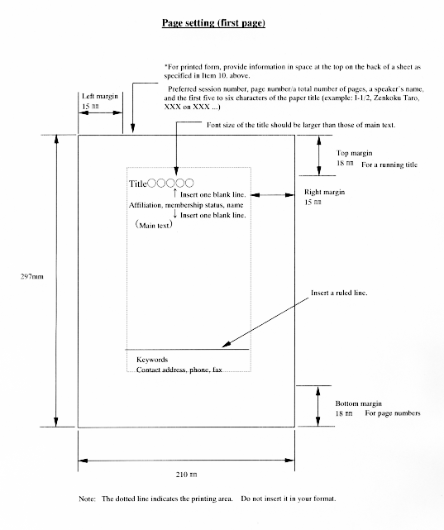
Fig. 1 Image of Paper

